**27. JUNIT TESTING TO CHECK WHETHER THE GIVEN STRING IS GETTING REVERSED OR NOT**

**AIM :**

To Perform Junit Testing to Check Whether the given string is getting Reversed or not.

**PROGRAM** :

**package** sse;

**import** **static** org.junit.Assert.assertEquals;

**import** java.util.Scanner;

**public** **class** reverse {

**public** **static** **void** main(String[] args)

{

String str;

**char** ch;

Scanner sc=**new** Scanner(System.***in***);

System.***out***.print("Enter a string : ");

str=sc.nextLine();

System.***out***.println("Reverse of a String '"+str+"' is :");

**for**(**int** j=str.length();j>0;--j)

{

System.***out***.print(str.charAt(j-1));

assertEquals("mani",str);

}

assertEquals("mani",str);

}

}

**OUTPUT:**

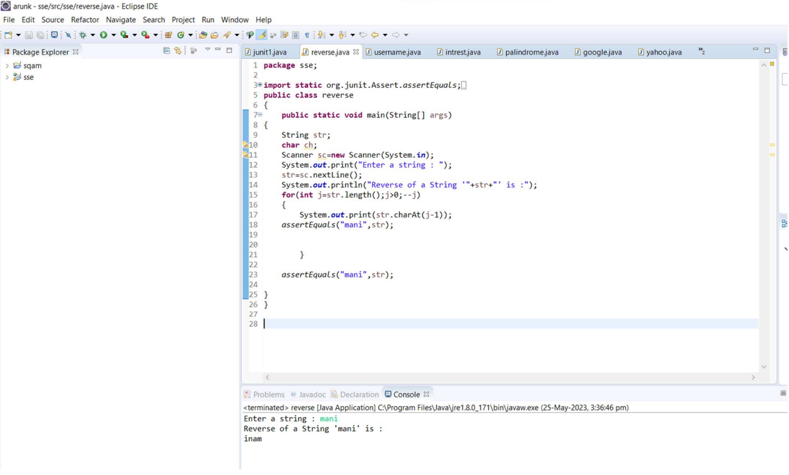

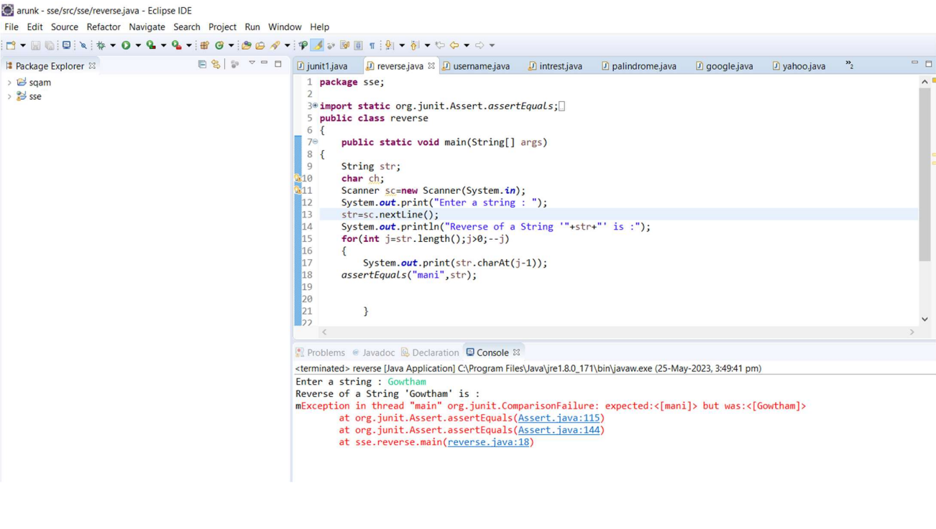

**RESULT:**

Hence the Junit Testing to Check Whether the given string is getting Reversed or not performed successfully.